Hand-Made Shallow ANN in Python

David Graves
Colorado State University Global
CSC510
Dr. Bingdong Li
September 25, 2025

Shallow Neural Network
An artificial neural network, or ‘ANN’ is a key tool in the data science tool belt that drives deeper understanding of complex and disparate data sets. ANN instances can be leveraged to help us see the signal within the noise of a massive dataset that may not be clear. These Shallow ANNs are, “essentially simplified abstractions of the human brain and its complex biological networks of neurons.” (Sharda & Delen & Turban, 2024) The algorithm does this by using feedforward functions, and backpropagation against an input(s) to train the ANN, that then produces a novel output based off new input from a user that mimics actual intelligence. I will share an algorithm I designed that anticipates the fourth number when three individual numbers are input. This Shallow ANN has an input layer data as matrix, a hidden layer, an output layer, and weights between the layers as it spans 5,000 epochs. The algorithm is activated by simply running the program ‘Shallow_ANN.py’ as shown in Images 1-3 on the following pages. Once the program executes and ‘trains’ on the data set, the user is prompted to input three numbers as shown in Image 4. You will note that the Shallow ANN can produce a value close to what one would reason as the next number should be in different instances from arithmetic to geometric calculations as seen in the output. This ANN does this technically speaking by multiplying the input by a set of weights (lines 37-42), applying deliberate activation functions for every hidden layer (lines 93-99), calculating errors and outputting a gradient descent (lines 61-64), applying loss function to weights (lines 61-77), and repeating this process at least 1,000 times (lines 44-46) to train from the input matrix (lines 15-21).

Image 1
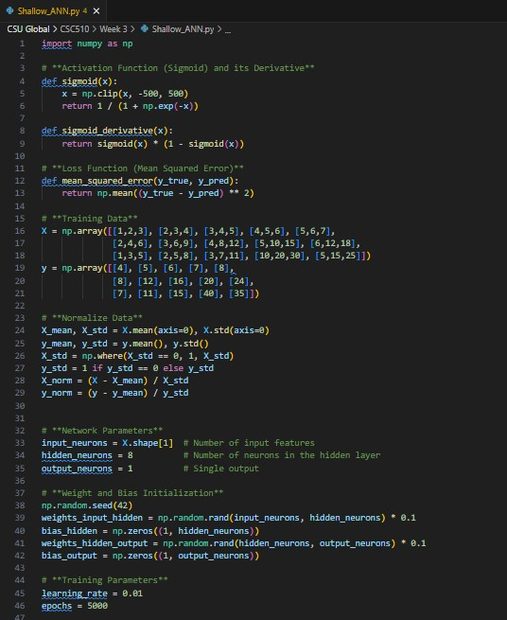
Image 2
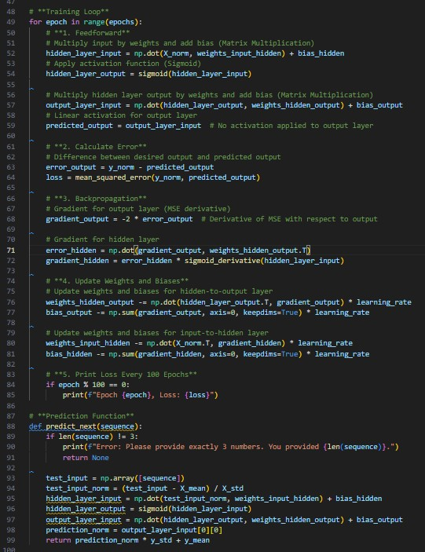
Image 3
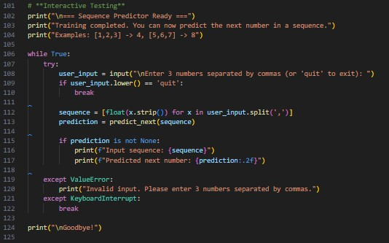
Image 4
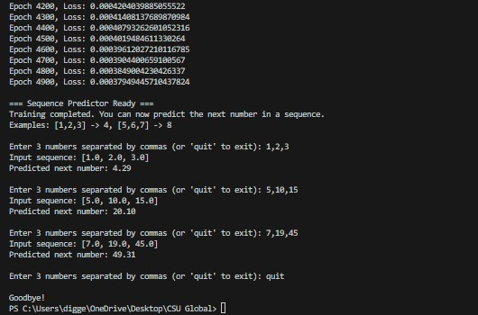
Reference
Sharda, Ramesh & Delen, Dursun & Turban, Efraim (2024). Business Intelligence, Analytics,
Data Science, and AI. Pearson Education Limited.

